THE SANTA ROSA BAND OF CAHUILLA INDIANS

WANTS TO INVITE YOU TO JOIN US FOR OUR ANNUAL EARTH DAY
JUNE 10th, 2023 @ 10AM-2PM

“Look After Our Mother Earth”

Our theme for this Earth Day is giving back to Mother Earth! We will be demonstrating ways in which YOU can do that in your everyday life. There will be giveaways, prizes, and food/drinks for all attendees.
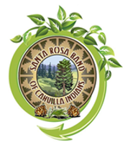

For more information give us a call
(951) 659-2700

